**PROJECT REPORT TEMPLATE**

1. **INTRODUCTION**
   1. **Overview**

Problem Understanding, also known as Problem Definition or Problem Identification, is the initial and critical phase of any data analysis or problem-solving process. It involves gaining a clear and comprehensive understanding of the problem at hand, its context, scope, and objectives.

* 1. **purpose**

Ultimately, the business requirement of the dataset is to enable stakeholders in the aviation industry to gain a competitive advantage by making data-driven decisions. By providing a comprehensive collection of data related to the air transportation network, the dataset can help stakeholders stay ahead of the curve in a dynamic and rapidly changing industry.

1. **Problem definition and Design thinking** 
   1. **Empathy Map**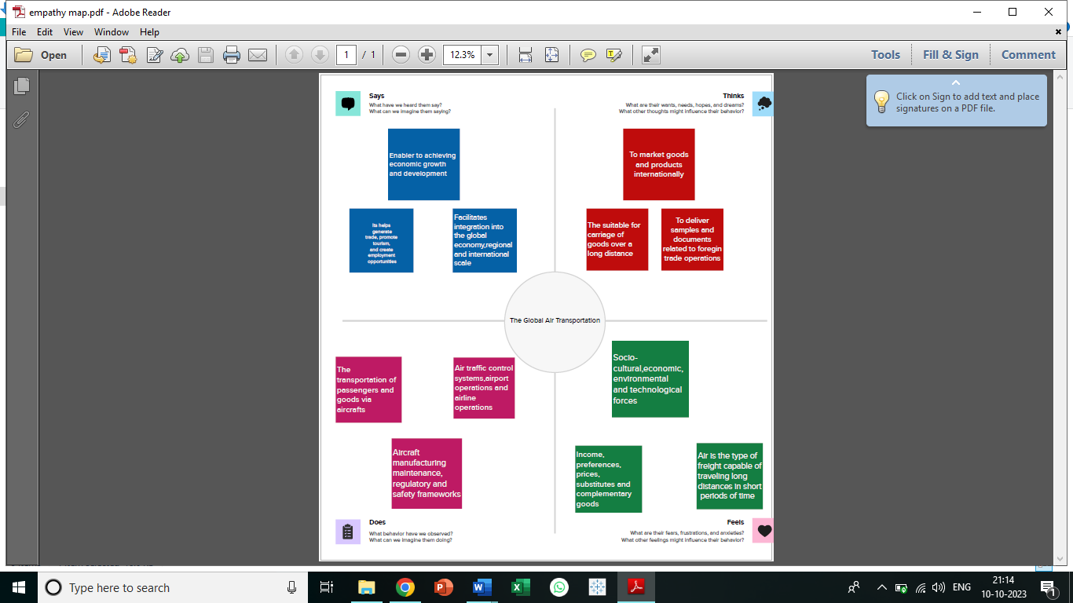

* 1. **Brainstorming map**

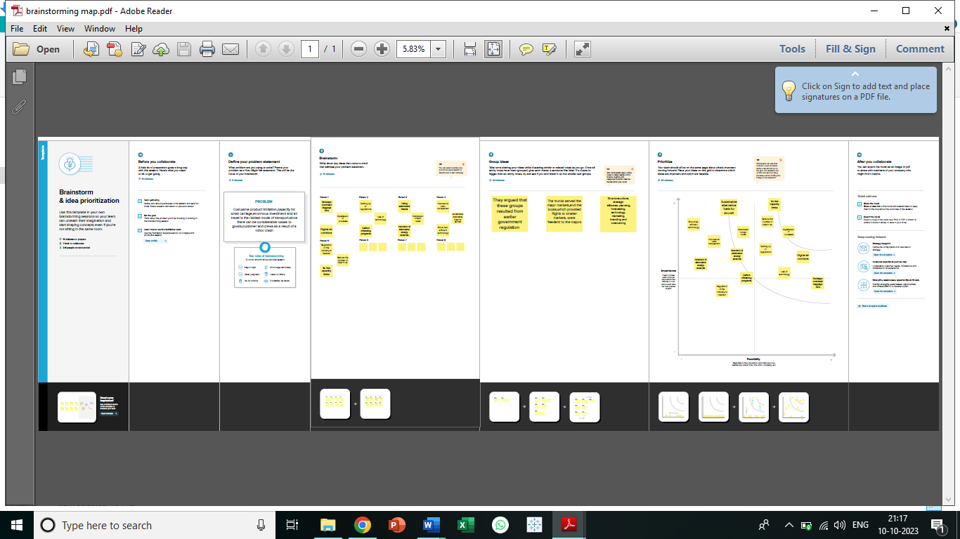

1. **Result**

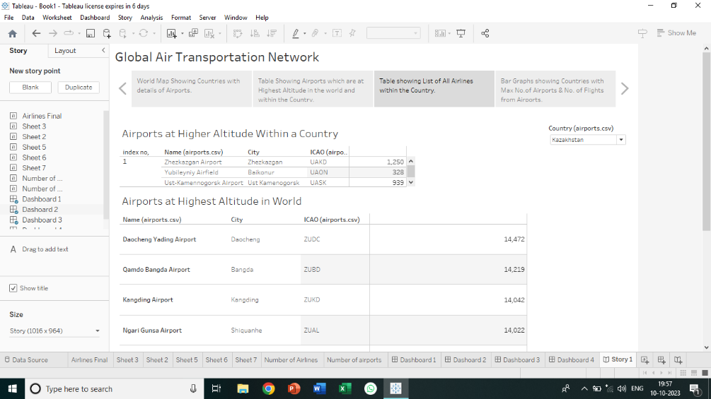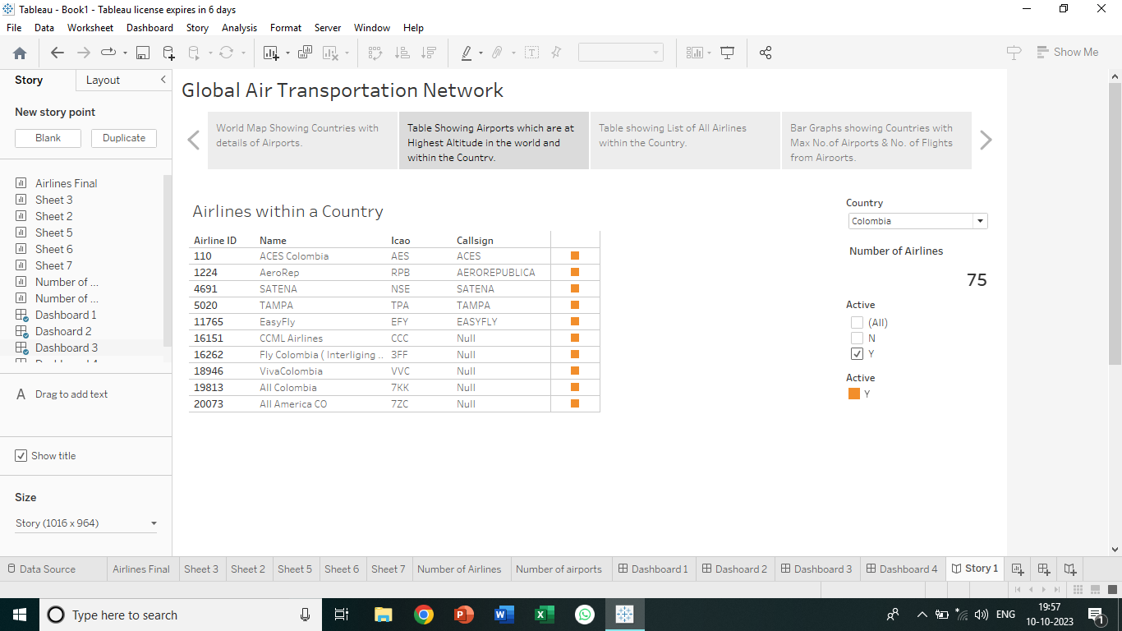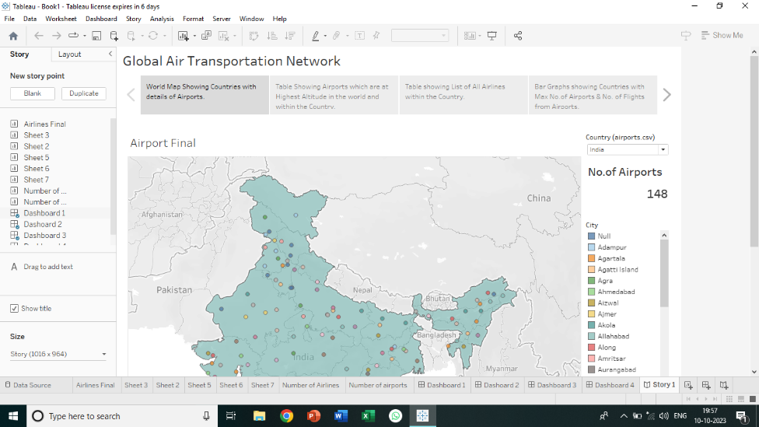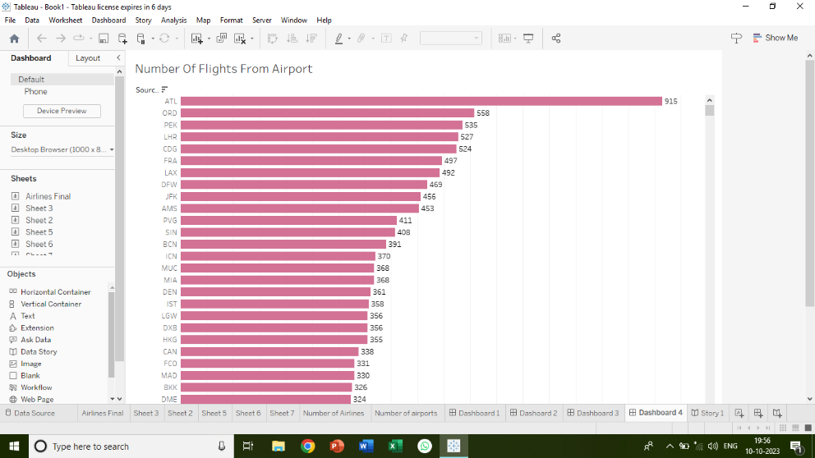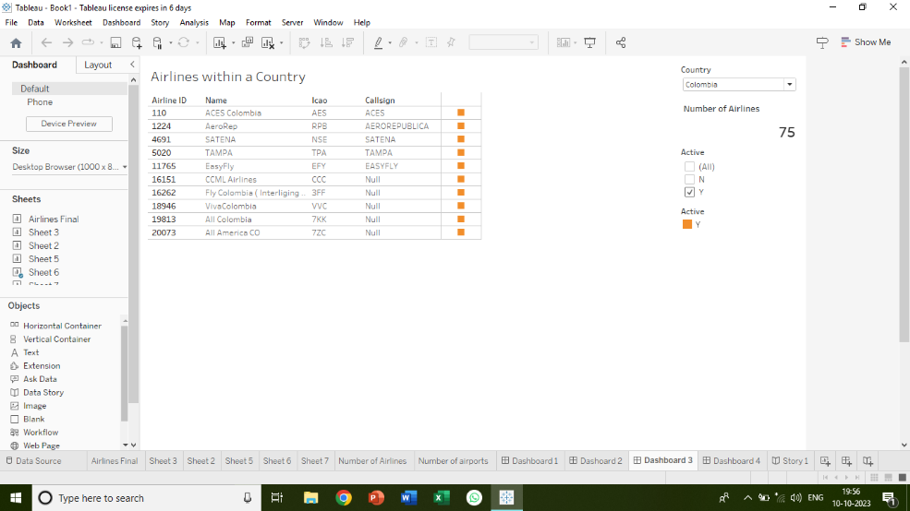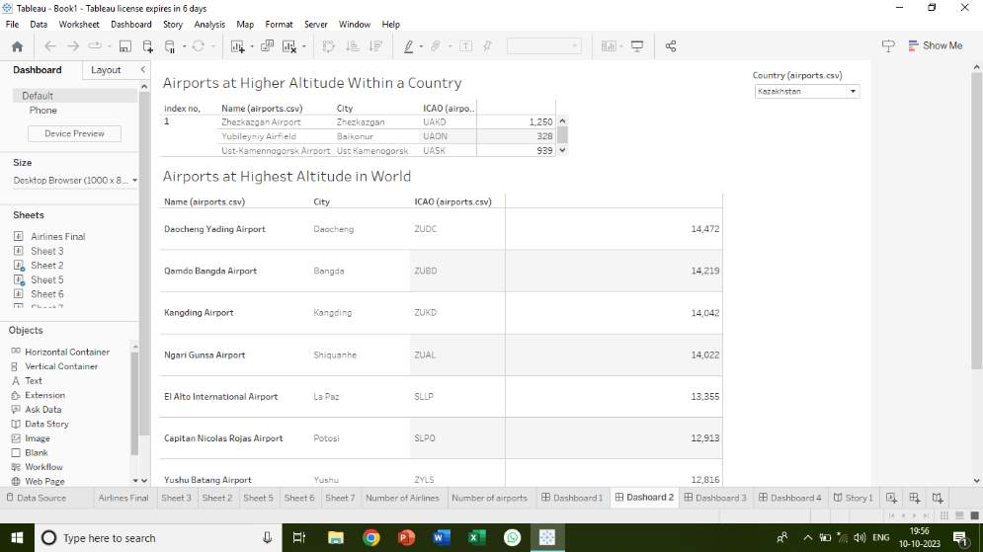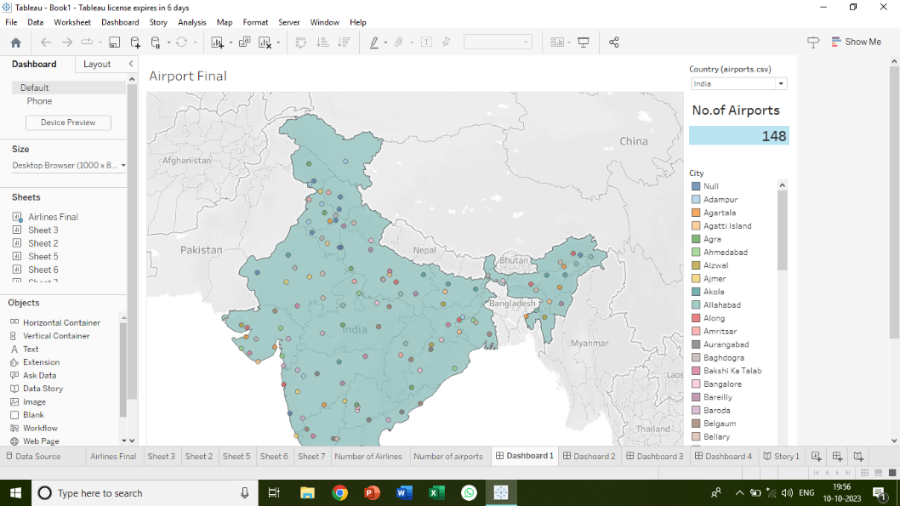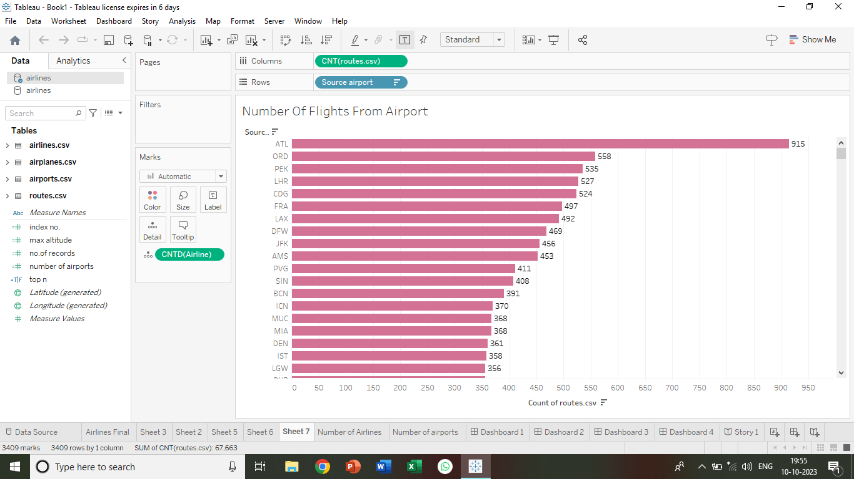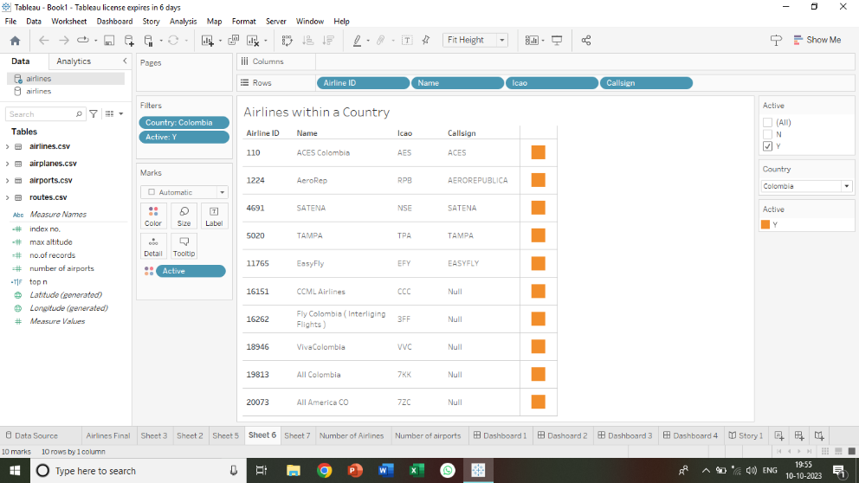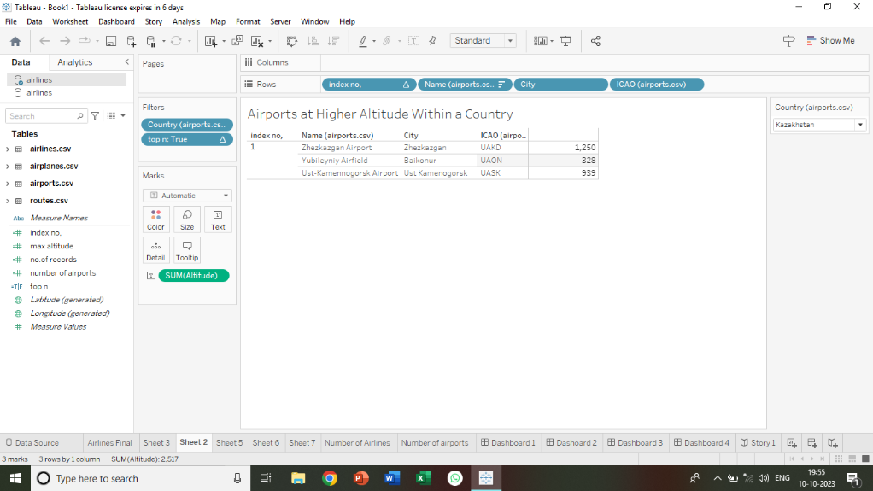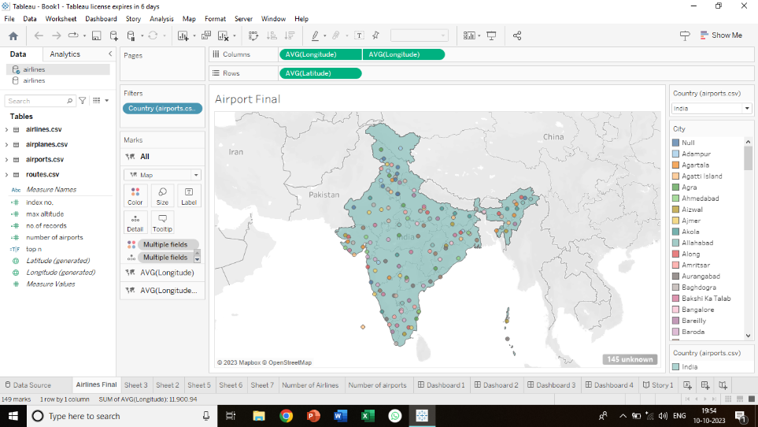

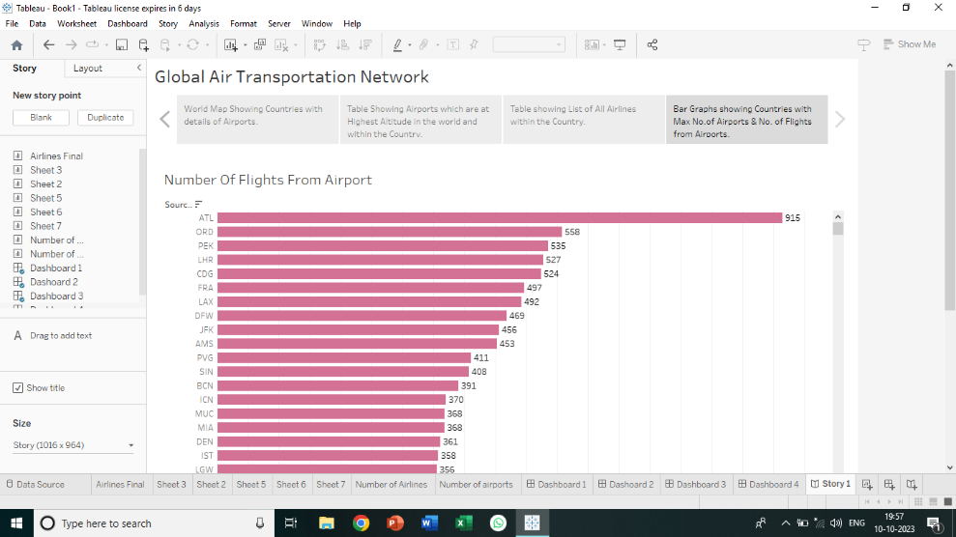

1. **Advantages and Dis advantages**

# Advantages and Disadvantages of Air Transport.

# Advantages of Air Transport. High Speed. Fast Service. Send almost everywhere your freight. ...

# Disadvantages of Air Transport. Risky. Cost. Some Product Limitation. ...

# What do I know before flying my goods?

# Calculate your freight.

1. **Applications**

Modeling air transport networks aims airline companies to organize their routes in a cost-efficient way and therefore maximize their profits. Air transport network models are also the tool to investigate system robustness. They help to determine weaknesses of the system in case of various kinds of disruptions.[[4]](https://en.wikipedia.org/wiki/Air_Transport_Network#cite_note-Lordan-4)[[6]](https://en.wikipedia.org/wiki/Air_Transport_Network#cite_note-Hu-6) Once weaknesses are determined, a substitute node which can support all or part of the traffic load can be identified through the alternative strength for the pair.[[7]](https://en.wikipedia.org/wiki/Air_Transport_Network#cite_note-7)

An alternative application is modeling human disease networks. Air transport network is used by millions of people every day, therefore it plays key role in the spread of some infections, such as influenza or [SARS](https://en.wikipedia.org/wiki/SARS). In this sense air transport network is a transmitter similar to [sexual networks](https://en.wikipedia.org/wiki/Sexual_network), which is liable for the spread of AIDS and other sexually transmitted diseases.[[2]](https://en.wikipedia.org/wiki/Air_Transport_Network#cite_note-Gui-2)[[3]](https://en.wikipedia.org/wiki/Air_Transport_Network#cite_note-Gui2-3)

1. **conclusion**

The business requirement of the Global Air Transportation Network- Airports, Airlines, and Routes dataset is to provide stakeholders in the aviation industry with accurate, up-to-date information on the worldwide air transportation network. The dataset is intended to help stakeholders make informed decisions related to business growth, investment, capacity planning, and infrastructure development.

1. **Future scope**

The most recent estimates suggest that demand for air transport will increase by an average of 4.3% per annum over the next 20 years. If this growth path is achieved by 2036 the air transport industry will then contribute 15.5 million in direct jobs and $1.5 trillion of GDP to the world economy.

1. **Appendix**
2. **Source code**